# ScanSnap Scanning (sheet feeder)

### Ensure the scanner is clean

Firstly please make sure that the scanner windows are clean. To clean the scanner windows use:

1. Open the scanner using the tab to the top right of the unit (for photos see Appendix 3)
2. Get a lens cloth from the shelf next to the scanner and wet it with Isoclene fluid (Isopropyl alcohol)
3. Wipe both of the windows to clean all marks off them – generally the marks are vertical lines close to the edges of the scanning window

If the scanning window is not clean then vertical lines will appear on all scanned documents

### Scanning a Document

To scan with ScanSnap you should just need to:

1) Put the document in the ScanSnap

2) Press the Scan button on the ScanSnap

The document should be scanned. Popups will occur for sheet feeder errors, etc.

### How to tell if it worked

If the document gets fed through the scanner and no boxes pop up to say that there are problems then the scan has been completed

### Problem Solving

If the scanner doesn't work then it might be a problem that can be fixed by pulling out the power and data cables on the back of the scanner and plugging them back in again. If this doesn't work try restarting the computer using the Power menu on Windows (press the Windows button for instance to see the 0/1 symbol).

The settings for ScanSnap Home (the ScanSnap software are):

Scan to Folder

Colour, Duplex, Auto Image Quality, Auto Rotation, PDF

Scan to file: c:\Users\rob\Documents\ScanSnap

Send to none: Scan to file

See Appendix 1 below for full information on settings.

# PaperScan Scanning (flat bed)

Start the PaperScan software using the icon on the desktop.

Click Acquire and then Start Wizard and you should see:

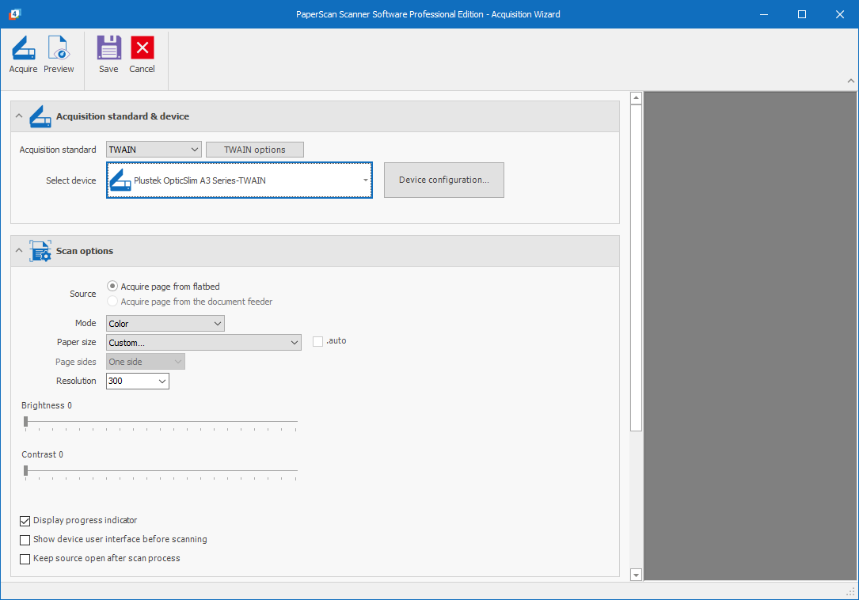

Please make sure it says “Plustek OpticSlim A3 Series-TWAIN” in the drop down menu.

Also generally scanning should be done in Mode: Color at Resolution: 300

### Scanning the Document

Finally press the Acquire button (on the Wizard top left) and you should hear whirring and eventually a screen like this will appear:

### Scanning Additional Pages

If you are scanning a multi-page document then you can scan additional pages now. You will see the set of pages in the left hand side of the screen after each page is scanned. You can select them individually and re-order or delete them as appropriate.

### Saving the scan

Once you have all the pages scanned (even if it is only one page) press the Save button and you should see:

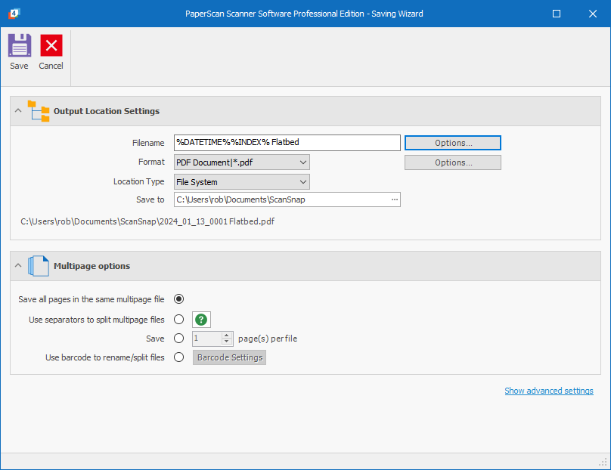

ONLY continue beyond this point if the settings look exactly like this. DO NOT change the folder to scan into. If the Filename is not exactly as shown above then click the Options button next to the Filename box and you should see:

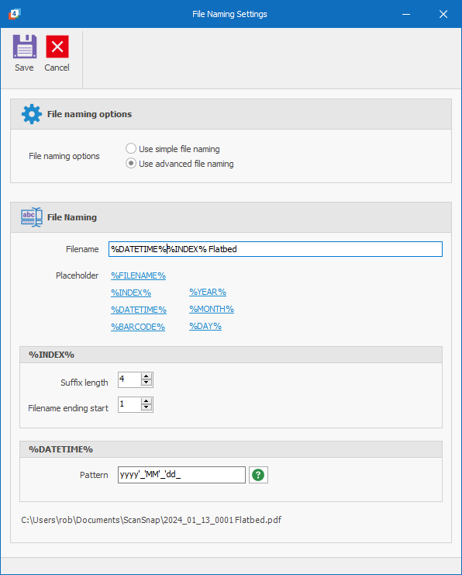

# Appendix 1 ScanSnap Settings

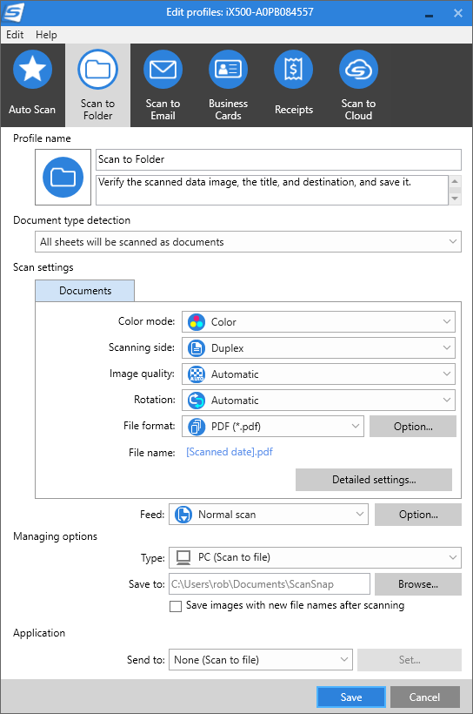

# Appendix 2 Cleaning the Sheet FeD Scanner (ScanSnap)

Open the scanner using the tab shown below:

Look carefully at the windows that the scanner uses to read the document – these are two clear plastic strips inside the scanner:

Check for any marks on these windows – the might look like this:

Often you can feel them with your fingertips more easily than seeing them.

If you find any marks then get a lens cleaning cloth and wet it with Isoclene and clean the marks off both windows before scanning.